**LAPORAN MANAJEMENT PROYEK TEKNOLOGI INFORMASI**

**PEMBANGUNAN SISTEM INFORMASI DESA JATITUJUH**

**KANTOR PEMERINTAH DESA JATI TUJUH**

**Poin 1**



Oleh :

Nama : Afif Nurwidianto

Nim : 2000018131

Kelas : B

**FAKULTAS TEKNOLOGI INDUSTRI**

**PRODI TEKNIK INFORMATIKA**

**UNIVERSITAS AHMAD DAHLAN**

**YOGYAKARTA**

**2022**

**DIAGRAM PATH / LISTING KODE**

**Point 2**

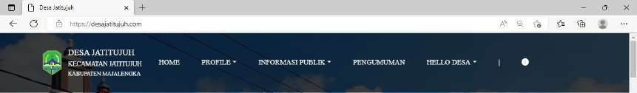**Navbar halaman pengunjung**

<div class ="container py-4">

<img src="/img/logo-desajatituju.png" width="45px" height="60px" alt="" srcset="">

<p class="box-title-desa">

<span class="desa-1">DESA JATITUJUH</span><br>

<span class="desa-2">KECAMATAN JATITUJUH</span><br>

<span class="desa-3">KABUPATEN MAJALENGKA</span>

</p>

<button class="navbar-toggler" type="button" data-bs- toggle="collapse" data-bs-target="#navbarNav" aria-controls="navbarNav" aria- expanded="false" aria-label="Toggle navigation">

<span class="navbar-toggler-icon"></span>

</button>

<div class="collapse navbar-collapse" id="navbarNav">

<ul class="navbar-nav">

<li class="nav-item">

<a class="nav-link" href="<?php echo base_url('/');?>">HOME</a>

</li>

<div class="dropdown">

<li class="nav-item">

<a class="nav-link dropdown-toggle" href="#" role="button" id="dropdownMenuLink" data-bs-toggle="dropdown" aria- expanded="false">PROFILE</a>

<ul class="dropdown-menu bg-dark text-white" aria- labelledby="dropdownMenuLink">

<li><a class="dropdown-item" href="<?php echo base_url('/sejarah-desa');?>">Sejarah Desa</a></li>

<li><a class="dropdown-item" href="<?php echo base_url('/pemerintahan-desa');?>">Pemerintahan Desa</a></li>

<li><a class="dropdown-item" href="<?php echo base_url('/visi-misi');?>">Visi Misi</a></li>

<li><a class="dropdown-item"

href="#">Demografi</a></li>

<li><a class="dropdown-item"

href="#">Statistik</a></li>

<li><a class="dropdown-item" href="#">Kelembagaan</a></li>

</ul>

</li>

</div>

<div class="dropdown">

<li class="nav-item">

<a class="nav-link dropdown-toggle" href="#" role="button" id="dropdownMenuLink" data-bs-toggle="dropdown" aria- expanded="false">INFORMASI PUBLIK</a>

<ul class="dropdown-menu bg-dark text-white" aria- labelledby="dropdownMenuLink">

<li><a class="dropdown-item"

href="#">Berita</a></li>

<li><a class="dropdown-item"

href="#">Event</a></li>

<li><a class="dropdown-item"

href="#">Galeri</a></li>

</ul>

</li>

</div>

<li class="nav-item">

<a class="nav-link" href="#">PENGUMUMAN</a>

</li>

<div class="dropdown">

<li class="nav-item">

<a class="nav-link dropdown-toggle" href="#" role="button" id="dropdownMenuLink" data-bs-toggle="dropdown" aria- expanded="false">HELLO DESA</a>

<ul class="dropdown-menu bg-dark text-white" aria- labelledby="dropdownMenuLink">

<li><a class="dropdown-item" href="<?php echo base_url('/kontak');?>">Kontak</a></li>

<li><a class="dropdown-item" href="#">Laporan

Terkini</a></li>

</ul>

</li>

</div>

<li class="nav-item">

<a class="nav-link">|</a>

</li>

<li class="nav-item">

<a class="nav-link" href="#"><i class="fa-solid fa- magnifying-glass"></i></a>

</li>

<li class="nav-item">

<a class="nav-link" href="#"><i class="fa-solid fa- circle-exclamation"></i></a>

</li>

</ul>

</div>

</div>

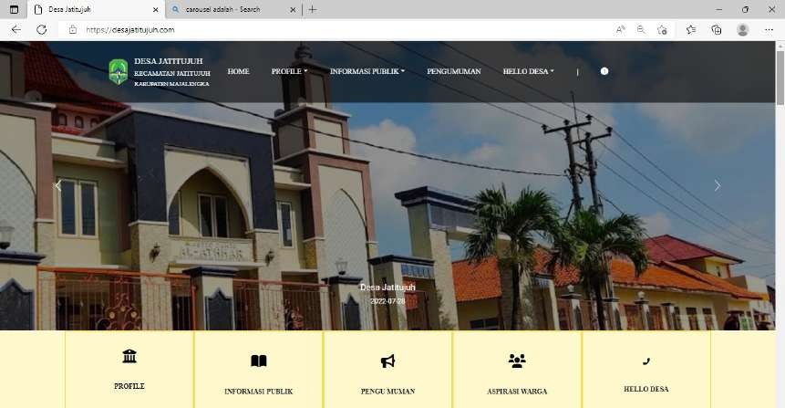**Sorce code controller pengunjung.php**

<!-- start navbar -->

<?= $this->extend('layout/page_layout') ?>

<!-- end navbar -->

<!-- start carousel -->

<?= $this->Section('content') ?>

<div id="carouselExampleControls" class="carousel slide carousel-fade" data-bs-ride="carousel">

<div class="carousel-indicators">

<button type="button" data-bs-target="#carouselExampleCaptions" data- bs-slide-to="0" class="active" aria-current="true" aria-label="Slide 1"></button>

<button type="button" data-bs-target="#carouselExampleCaptions" data- bs-slide-to="1" aria-label="Slide 2"></button>

<button type="button" data-bs-target="#carouselExampleCaptions" data- bs-slide-to="2" aria-label="Slide 3"></button>

</div>

<div class="carousel-inner">

<div class="carousel-item active" data-bs-interval="2000">

<img src="/img/desajatituju.jpg" class="img-size d-block w-100" alt="...">

<div class="carousel-caption d-none d-md-block">

<h5>First slide label</h5>

<p>Some representative placeholder content for the first

slide.</p>

</div>

</div>

<div class="carousel-item" data-bs-interval="2000">

<img src="/img/WhatsApp Image 2022-04-26 at 21.29.46.jpeg" class="img-size d-block w-100" alt="...">

<div class="carousel-caption d-none d-md-block">

<h5>Second slide label</h5>

<p>Some representative placeholder content for the second

slide.</p>

</div>

</div>

<div class="carousel-item" data-bs-interval="2000">

<img src="/img/WhatsApp Image 2022-04-26 at 21.30.05.jpeg" class="img-size d-block w-100" alt="...">

<div class="carousel-caption d-none d-md-block">

<h5>Third slide label</h5>

<p>Some representative placeholder content for the third

slide.</p>

</div>

</div>

</div>

<button class="carousel-control-prev" type="button" data-bs- target="#carouselExampleControls" data-bs-slide="prev">

<span class="carousel-control-prev-icon" aria-hidden="true"></span>

<span class="visually-hidden">Previous</span>

</button>

<button class="carousel-control-next" type="button" data-bs- target="#carouselExampleControls" data-bs-slide="next">

<span class="carousel-control-next-icon" aria-hidden="true"></span>

<span class="visually-hidden">Next</span>

</button>

</div>

<!-- end carousel -->

<!-- start menu button -->

<div class="box-btn">

<!-- <div class="box-btn-link text-center">

<a href="#" class="">

<i class="fa-solid fa-house-user"></i><br> HOME

</a>

<a href="#" class="">

<i class="fa-solid fa-house-user"></i><br> INFORMASI PUBLIK

</a>

<a href="#" class="">

<i class="fa-solid fa-house-user"></i> HOME

</a>

<a href="#" class="">

<i class="fa-solid fa-house-user"></i> HOME

</a>

<a href="#" class="">

<i class="fa-solid fa-house-user"></i> HOME

</a>

<a href="#" class="">

<i class="fa-solid fa-house-user"></i> HOME

</a>

</div> -->

<div class="d-flex justify-content-center bg-flex">

<div class="btn-menu text-center">

<div class="btn-icon">

<i class="fa-solid fa-building-columns fa-4x"></i>

</div>

<div class="btn-text">

<p>PROFILE</p>

</div>

</div>

<div class="btn-menu text-center">

<div class="btn-icon">

<i class="fa-solid fa-book-open fa-4x"></i>

</div>

<div class="btn-text">

<p>INFORMASI PUBLIK</p>

</div>

</div>

<div class="btn-menu text-center">

<div class="btn-icon">

<i class="fa-solid fa-bullhorn fa-4x"></i>

</div>

<div class="btn-text">

<p>PENGUMUMAN</p>

</div>

</div>

<div class="btn-menu text-center">

<div class="btn-icon">

<i class="fa-solid fa-users fa-4x"></i>

</div>

<div class="btn-text">

<p>ASPIRASI WARGA</p>

</div>

</div>

<div class="btn-menu text-center">

<div class="btn-icon">

<i class="fa-solid fa-phone fa-4x"></i>

</div>

<div class="btn-text">

<p>HELLO DESA</p>

</div>

</div>

</div>

</div>

<!-- end menu button -->

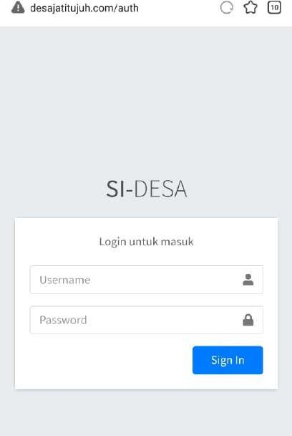**Halaman login admin**

public function auth() {

$validation = $this->validate([ 'user' => [

'rules' => 'required', 'errors' => [

'required' => 'Username tidak boleh kosong',

]

],

'pass' => [

'rules' => 'required', 'errors' => [

'required' => 'Password tidak boleh kosong',

]

],

]);

Controller login.php

<?php

namespace App\Controllers; use App\Models\ModelLogin;

class Login extends BaseController

{

public function construct()

{

$this->model = new ModelLogin();

}

public function index()

{

return view('sides/dashbord/login/index');

}

public function auth()

{

$validation = $this->validate([ 'user' => [

'rules' => 'required', 'errors' => [

'required' => 'Username tidak boleh kosong',

]

],

'pass' => [

'rules' => 'required', 'errors' => [

'required' => 'Password tidak boleh kosong',

]

],

]);

if (!$validation) {

return redirect()->to('auth')->withInput();

} else {

$user = $this->request->getPost('user');

$pass = $this->request->getPost('pass');

$isSucces = $this->prosesAuth($user, $pass); return $isSucces;

}

}

public function prosesAuth($user, $pass)

{

$model = $this->model->isAkun($user); if (!$model) {

session()->setFlashdata('alert', true); return redirect()->to('/auth');

}

// dd(password_hash("admin", PASSWORD_BCRYPT)); if (!password_verify($pass, $model->password)) { session()->setFlashdata('alert', true);

return redirect()->to('/auth');

} else {

$newdata = [

'username' => $user,

'password' => $model->password, 'level' => $model->level, 'isLogged' => true

];

session()->set($newdata); return redirect()->to('sides');

}

}

}

Model akun.php

<?php

namespace App\Models; use CodeIgniter\Model;

class ModelAkun extends Model

{

protected $table = 'akun'; protected $primaryKey = 'id'; protected $allowedFields = [

'nama_depan', 'nama_belakang', 'username',

'password',

'level',

'email', 'nomor_hp'

];

protected $useTimestamps = true; protected $createdField = 'created_at'; protected $updatedField = 'updated_at'; public function construct()

{

$this->database = db_connect();

}

public function show()

{

$sql = "

SELECT * FROM akun

";

return $this->database->query($sql)->getResult();

}

public function getAkunById($id)

{

$sql = "

SELECT

* FROM akun

WHERE akun.id = '" . $id . "'

";

return $this->database->query($sql)->getRow();

}

// public function update()

// {

// return $this->database->update($data, ['id' => $id]);

// }

public function updateById($data, $id)

{

return $this->database->table('akun')->update($data, ['id' =>

$id]);

}

public function deleteById($id)

{

return $this->database->delete(['id' => $id]);

}

public function checkUsername($username)

{

$sql = "

SELECT

akun.username FROM akun

WHERE akun.username = '" . $username . "'

";

return $this->database->query($sql)->getRow();

}

// ... }

**DIAGRAM AUTH**

1. Start
2. If username & password = true
3. Proses 🡪 Halaman admin
4. Else if username & password = false
5. Proses 🡪 Halaman login Admin
6. End if
7. Halaman Pengunjung
8. If data > 0
9. Add new data
10. Else if ! data > 0
11. Error add data
12. End

**Cyclomatic complexity**

**Point 3**

1. Pertama 1 sampai 12
2. Kedua 1-2-3 4-12
3. Ketiga 1-2-3-7-8-12
4. Keempat 1-2-3-7-8-10-11

Cyclomatix complexity V (G) untuk grafik alir di hitung dengan rumus

V(G) = E – N + 2

Dimana :

E = Jumlah edgen pada grafik alir

N = Jumlah node pada grafik alir

Pada Path yang telah di buat dapat di hitung

1. Flowgraph mempunyai 4 region
2. V(G) = 14 edge – 12 node + 3 = 5
3. V(G) = 4 predicate node + 1 = 5

jadi, cyclomatic complexity untuk flowgraph adalah

**TABLE KOMPLEKSITAS**

**Point 4**

* **Table 1** 1 sampai 12

|  |  |  |  |  |  |  |  |  |  |  |  |  |
| --- | --- | --- | --- | --- | --- | --- | --- | --- | --- | --- | --- | --- |
| No | 1 | 2 | 3 | 4 | 5 | 6 | 7 | 8 | 9 | 10 | 11 | 12 |
| 1 |  |  |  |  |  |  |  |  |  |  |  |  |
| 2 |  |  |  |  |  |  |  |  |  |  |  |  |
| 3 |  |  |  |  |  |  |  |  |  |  |  |  |
| 4 |  |  |  |  |  |  |  |  |  |  |  |  |
| 5 |  |  |  |  |  |  |  |  |  |  |  |  |
| 6 |  |  |  |  |  |  |  |  |  |  |  |  |
| 7 |  |  |  |  |  |  |  |  |  |  |  |  |
| 8 |  |  |  |  |  |  |  |  |  |  |  |  |
| 9 |  |  |  |  |  |  |  |  |  |  |  |  |
| 10 |  |  |  |  |  |  |  |  |  |  |  |  |
| 11 |  |  |  |  |  |  |  |  |  |  |  |  |
| 12 | 0 |  |  |  |  |  |  |  |  |  |  |  |

* **Table 2** 1-2-3 4-12

|  |  |  |  |  |  |  |  |  |  |  |  |  |
| --- | --- | --- | --- | --- | --- | --- | --- | --- | --- | --- | --- | --- |
| No | 1 | 2 | 3 | 4 | 5 | 6 | 7 | 8 | 9 | 10 | 11 | 12 |
| 1 | 0 |  |  |  |  |  |  |  |  |  |  |  |
| 2 |  | 0 |  |  |  |  |  |  |  |  |  |  |
| 3 |  |  | 0 |  |  |  |  |  |  |  |  |  |
| 4 |  |  |  | 0 |  |  |  |  |  |  |  |  |
| 5 |  |  |  |  |  |  |  |  |  |  |  |  |
| 6 |  |  |  |  |  |  |  |  |  |  |  |  |
| 7 |  |  |  |  |  |  |  |  |  |  |  |  |
| 8 |  |  |  |  |  |  |  |  |  |  |  |  |
| 9 |  |  |  |  |  |  |  |  |  |  |  |  |
| 10 |  |  |  |  |  |  |  |  |  |  |  |  |
| 11 |  |  |  |  |  |  |  |  |  |  |  |  |
| 12 |  |  |  |  |  |  |  |  |  |  |  | 0 |

* **Table 3** 1-2-3-37-8-12

|  |  |  |  |  |  |  |  |  |  |  |  |  |
| --- | --- | --- | --- | --- | --- | --- | --- | --- | --- | --- | --- | --- |
| No | 1 | 2 | 3 | 4 | 5 | 6 | 7 | 8 | 9 | 10 | 11 | 12 |
| 1 | 0 |  |  |  |  |  |  |  |  |  |  |  |
| 2 |  | 0 |  |  |  |  |  |  |  |  |  |  |
| 3 |  |  | 0 |  |  |  |  |  |  |  |  |  |
| 4 |  |  |  |  |  |  |  |  |  |  |  |  |
| 5 |  |  |  |  |  |  |  |  |  |  |  |  |
| 6 |  |  |  |  |  |  |  |  |  |  |  |  |
| 7 |  |  |  |  |  |  | 0 |  |  |  |  |  |
| 8 |  |  |  |  |  |  |  | 0 |  |  |  |  |
| 9 |  |  |  |  |  |  |  |  |  |  |  |  |
| 10 |  |  |  |  |  |  |  |  |  |  |  |  |
| 11 |  |  |  |  |  |  |  |  |  |  |  |  |
| 12 |  |  |  |  |  |  |  |  |  |  |  | 0 |
|  |

* Table 4 1-2-3-7-8-10-11

|  |  |  |  |  |  |  |  |  |  |  |  |  |
| --- | --- | --- | --- | --- | --- | --- | --- | --- | --- | --- | --- | --- |
| No | 1 | 2 | 3 | 4 | 5 | 6 | 7 | 8 | 9 | 10 | 11 | 12 |
| 1 | 0 |  |  |  |  |  |  |  |  |  |  |  |
| 2 |  | 0 |  |  |  |  |  |  |  |  |  |  |
| 3 |  |  | 0 |  |  |  |  |  |  |  |  |  |
| 4 |  |  |  |  |  |  |  |  |  |  |  |  |
| 5 |  |  |  |  |  |  |  |  |  |  |  |  |
| 6 |  |  |  |  |  |  |  |  |  |  |  |  |
| 7 |  |  |  |  |  |  | 0 |  |  |  |  |  |
| 8 |  |  |  |  |  |  |  | 0 |  |  |  |  |
| 9 |  |  |  |  |  |  |  |  |  |  |  |  |
| 10 |  |  |  |  |  |  |  |  |  | 0 |  |  |
| 11 |  |  |  |  |  |  |  |  |  |  | 0 |  |
| 12 |  |  |  |  |  |  |  |  |  |  |  |  |

**SKENARIO UJI**

**Point 5**

Pengujian white-box

* Halaman login admin
* Halaman Admin
* Halaman pengguna

Pengujian black-box

* Sekenario pengujian 1 : mengecek login halaman login admin
* Sekenario pengujian 2 : mengecek validasi ketika password salah dan username benar pada halaman login admin
* Sekenario pengujian 3 : mengecek validasi ketika memasukan username tidak valid dan password valid
* Sekenario pengujian 4 : mengecek validasi ketika username dan password kosong ketika login di halaman admin
* Sekenario pengujian 5 : mengecek validasi ketika username kosong dan password valid pada halaman login admin
* Sekenario pengujian 6 : mengecek validasi ketika username benar dan password kosong
* Sekenario pengujian 7 : mengecek ketika tidak menginputkan apapun pada form login admin
* Scenario pengujian 8 : mengecek validasi halaman admin
* Scenario pengujian 9 : mengecek function Tambah, edit, hapus data penduduk,content,aspirasi warga, dll.
* Scenario pengujian 10 : mengecek tampilan halaman halaman pengguna.

**PENGUJIAN WHITE BOX**

**Point 6**

Pengujian halaman pengguna ,halaman admin, dan halaman login admin

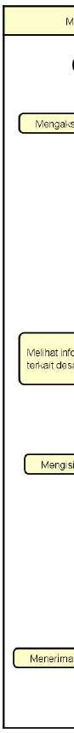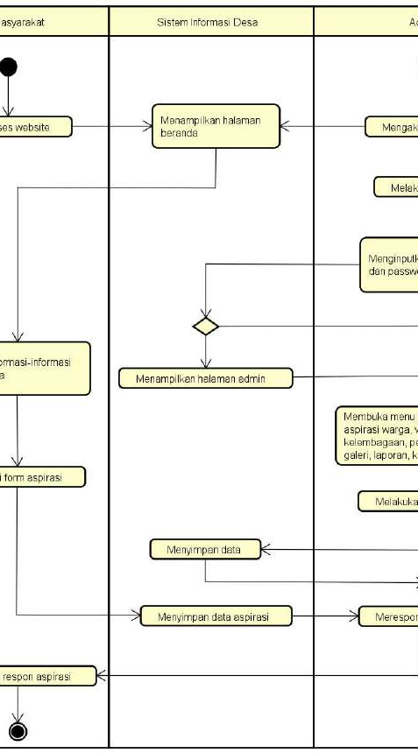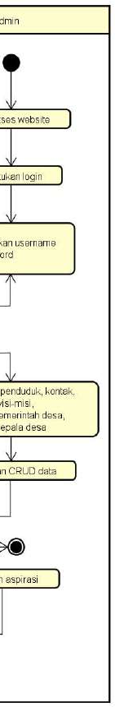

**PENGUJIAN BLACK BOX**

**Point 7**

* **Pengujian halaman login admin**

|  |  |  |  |  |  |
| --- | --- | --- | --- | --- | --- |
| No | Skenario Pengujian | Test Case | Hasil yang diharapkan | Hasil Pengujian | Kesimpulan |
| 1 | Username dan Password tidak diisi kemudian klik tombol Sign In | Username : (tidak diisi / kosong)  Password : (tidak diisi/ kosong) | Sistem akan menolak dan menampilkan pesan  “Username dan Password  tidak boleh kosong” | Sesuai harapan | Valid |
| 2 | Mengetikan Username, Password tidak diisi atau kosong kemudian klik  tombol Sign In | Username : admin  Password : (tidak diisi/ kosong) | Sistem akan menolak dan menampilkan pesan  “Password | Sesuai harapan | Valid |
|  |  |  | tidak boleh  kosong” |  |  |
| 3 | Mengetikan Password, Username tidak diisi atau kosong kemudian klik tombol Sign In | Username : (tidak diisi/ kosong)  Password  :admin | Sistem akan menolak dan menampilkan pesan  “Username tidak boleh kosong” | Sesuai harapan | Valid |
| 4 | Mengetikan Username dan Password tidak sesuai (salah), kemudian klik tombol Sign In | Username : Admin  Password : admin123 | Sistem akan menolak dan menampilkan pesan  “Username dan Password  salah” | Sesuai harapan | Valid |
| 5 | Mengetikan Username dan Password sesuai, kemudian klik tombol Sign In | Username : Admin  Password : admin | Sistem menerima akses login dan kemudian menampilkan halaman utama (Dashboard)  Admin | Sesuai harapan | Valid |

* **Pengujian halaman login**

|  |  |  |  |
| --- | --- | --- | --- |
| No | Fitur | Keterangan | Hasil Pengujian |
| 1 | Login | Sistem validasi | Sesuai |
| 2 | Penduduk | Tambah, edit, hapus data penduduk | Sesuai |
| 3 | Content | Tambah, edit, hapus data Content | Sesuai |
| 4 | Aspirasi Warga | Melakukan pencarian dan hapus data  aspirasi warga | Sesuai |
| 5 | Visi Misi | Mengedit atau menghapus data visi  misi | Sesuai |
| 6 | Kelembagaan | Tambah, edit, hapus data Kelembagaan | Sesuai |
| 7 | Pemerintah  Desa | Tambah, edit, hapus data Pemerintah  Desa | Sesuai |
| 8 | Galeri | Tambah, edit, hapus data galeri | Sesuai |
| 9 | Komentar | Menghapus data Komentar | Sesuai |
| 10 | Laporan | Tambah, edit, hapus data Laporan | Sesuai |
| 11 | Surat | Menghapus data Pemerintah Desa | Sesuai |
| 12 | KepalaDesa | Edit dan hapus data Kepala Desa | Sesuai |
| 13 | Logout | Keluar dari system dan akan ke direct halaman login admin | Sesuai |

* **Pengujian halaman pengguna**

|  |  |  |  |
| --- | --- | --- | --- |
| No | Fitur | Keterangan | Hasil Pengujian |
| 1 | Dashboard  (Beranda) | Menampilkan halaman utama sistem | Sesuai |
| 2 | Profile | Menampilkan halaman sejarah, pemerintahan, visi misi desa, demografi dan kelembagaan | Sesuai |
| 3 | Informasi Public | Menampilkan halaman berita, event dan galeri desa | Sesuai |
| 4 | Pengumuman | Menampilkan informasi atau berta- berita terupdate | Sesuai |
| 5 | Hello Desa | Menampilkan halaman kontak, laporan terkini, dan surat | Sesuai |

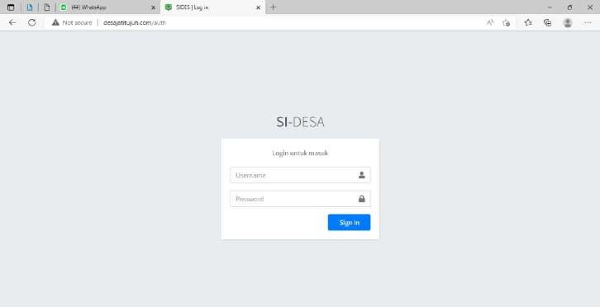Login admin

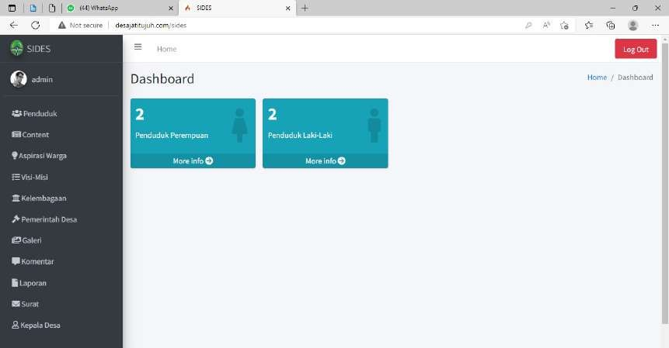Dashboard admin

Halaman utama pengunjung

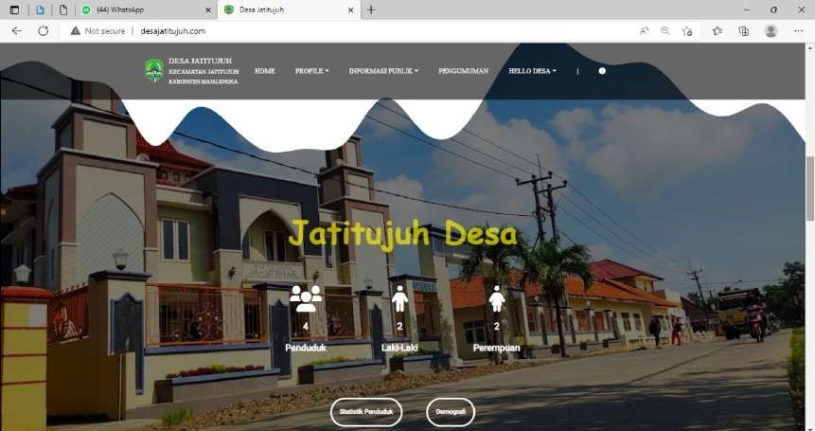

**Hasil Review**

1. Review

Berdasarkan hasil dari pengujian website <http://desajatitujuh.com/> pada saat menggunakan website, user tidak perlu login dan dapat langsung menggunakan fitur yang tersedia seperti :

Home

Profile >

* Sejsrah desa
* Pemerintah desa
* Visi Misi
* Demografi
* kelembagaan

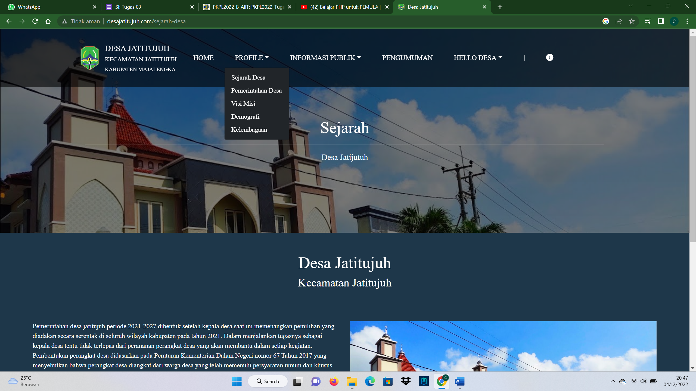

Informasi Publik >

* Berita
* Event
* Galeri

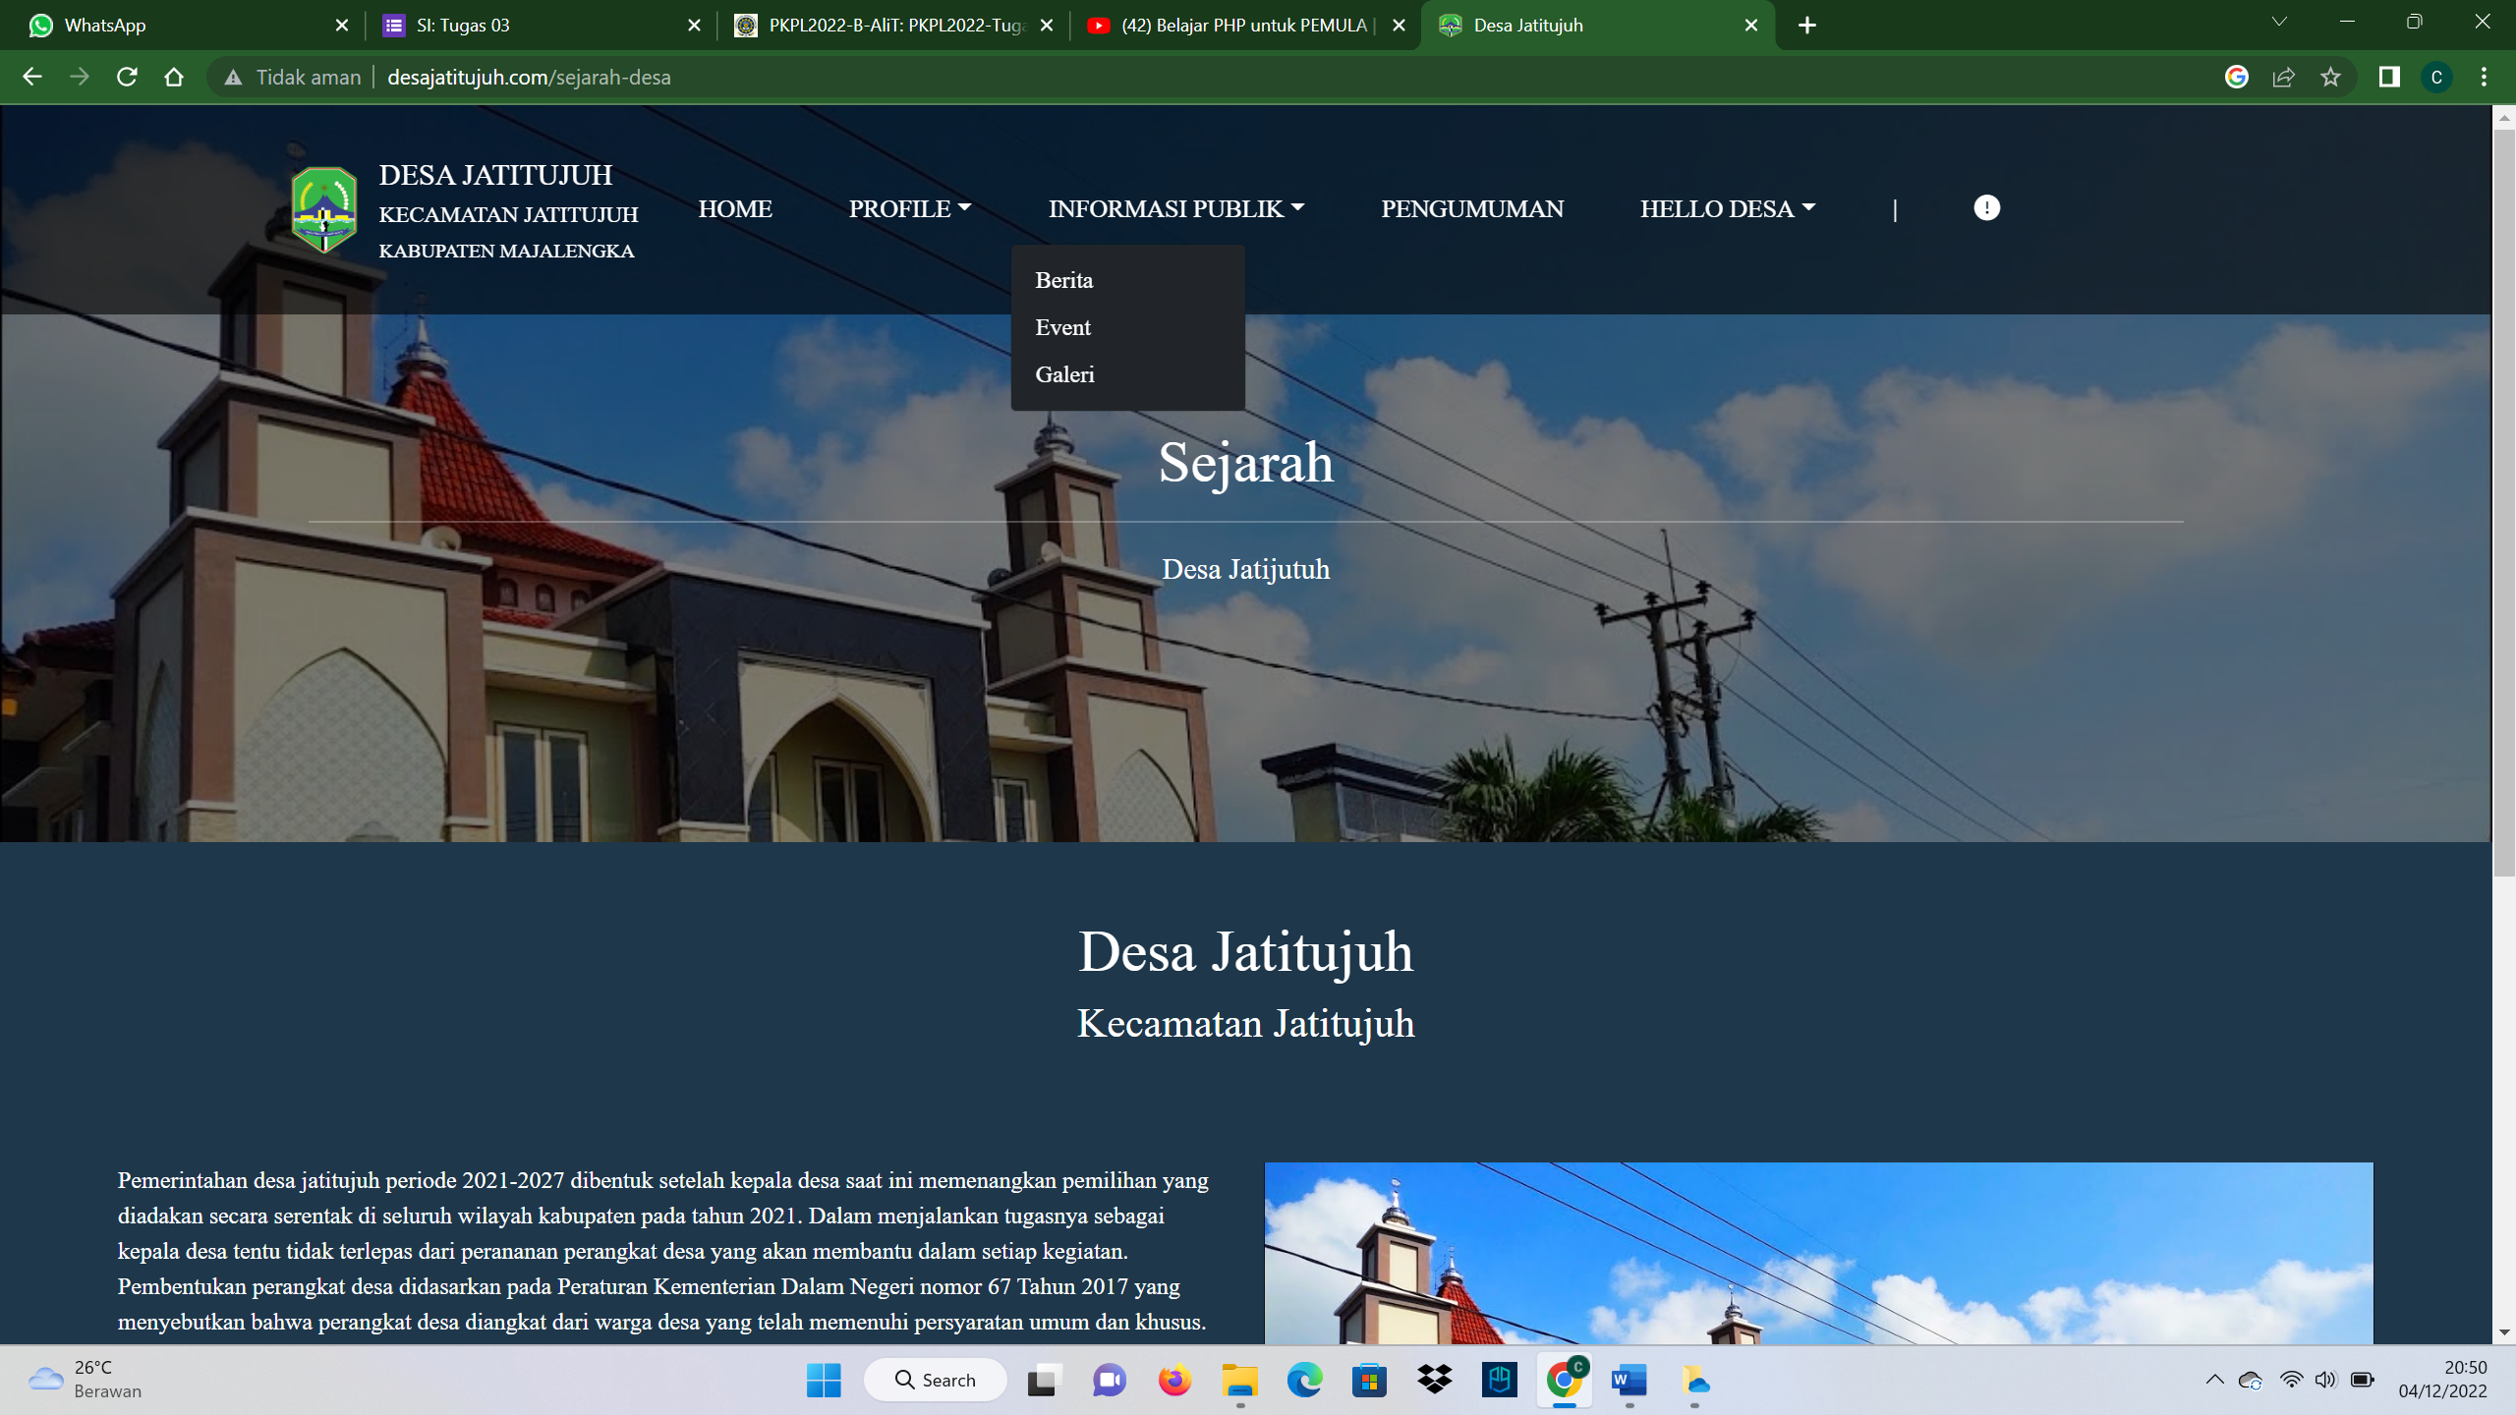

Pengumuman

Hello Desa >

* Kontak
* Laporan Tekini
* Surat Online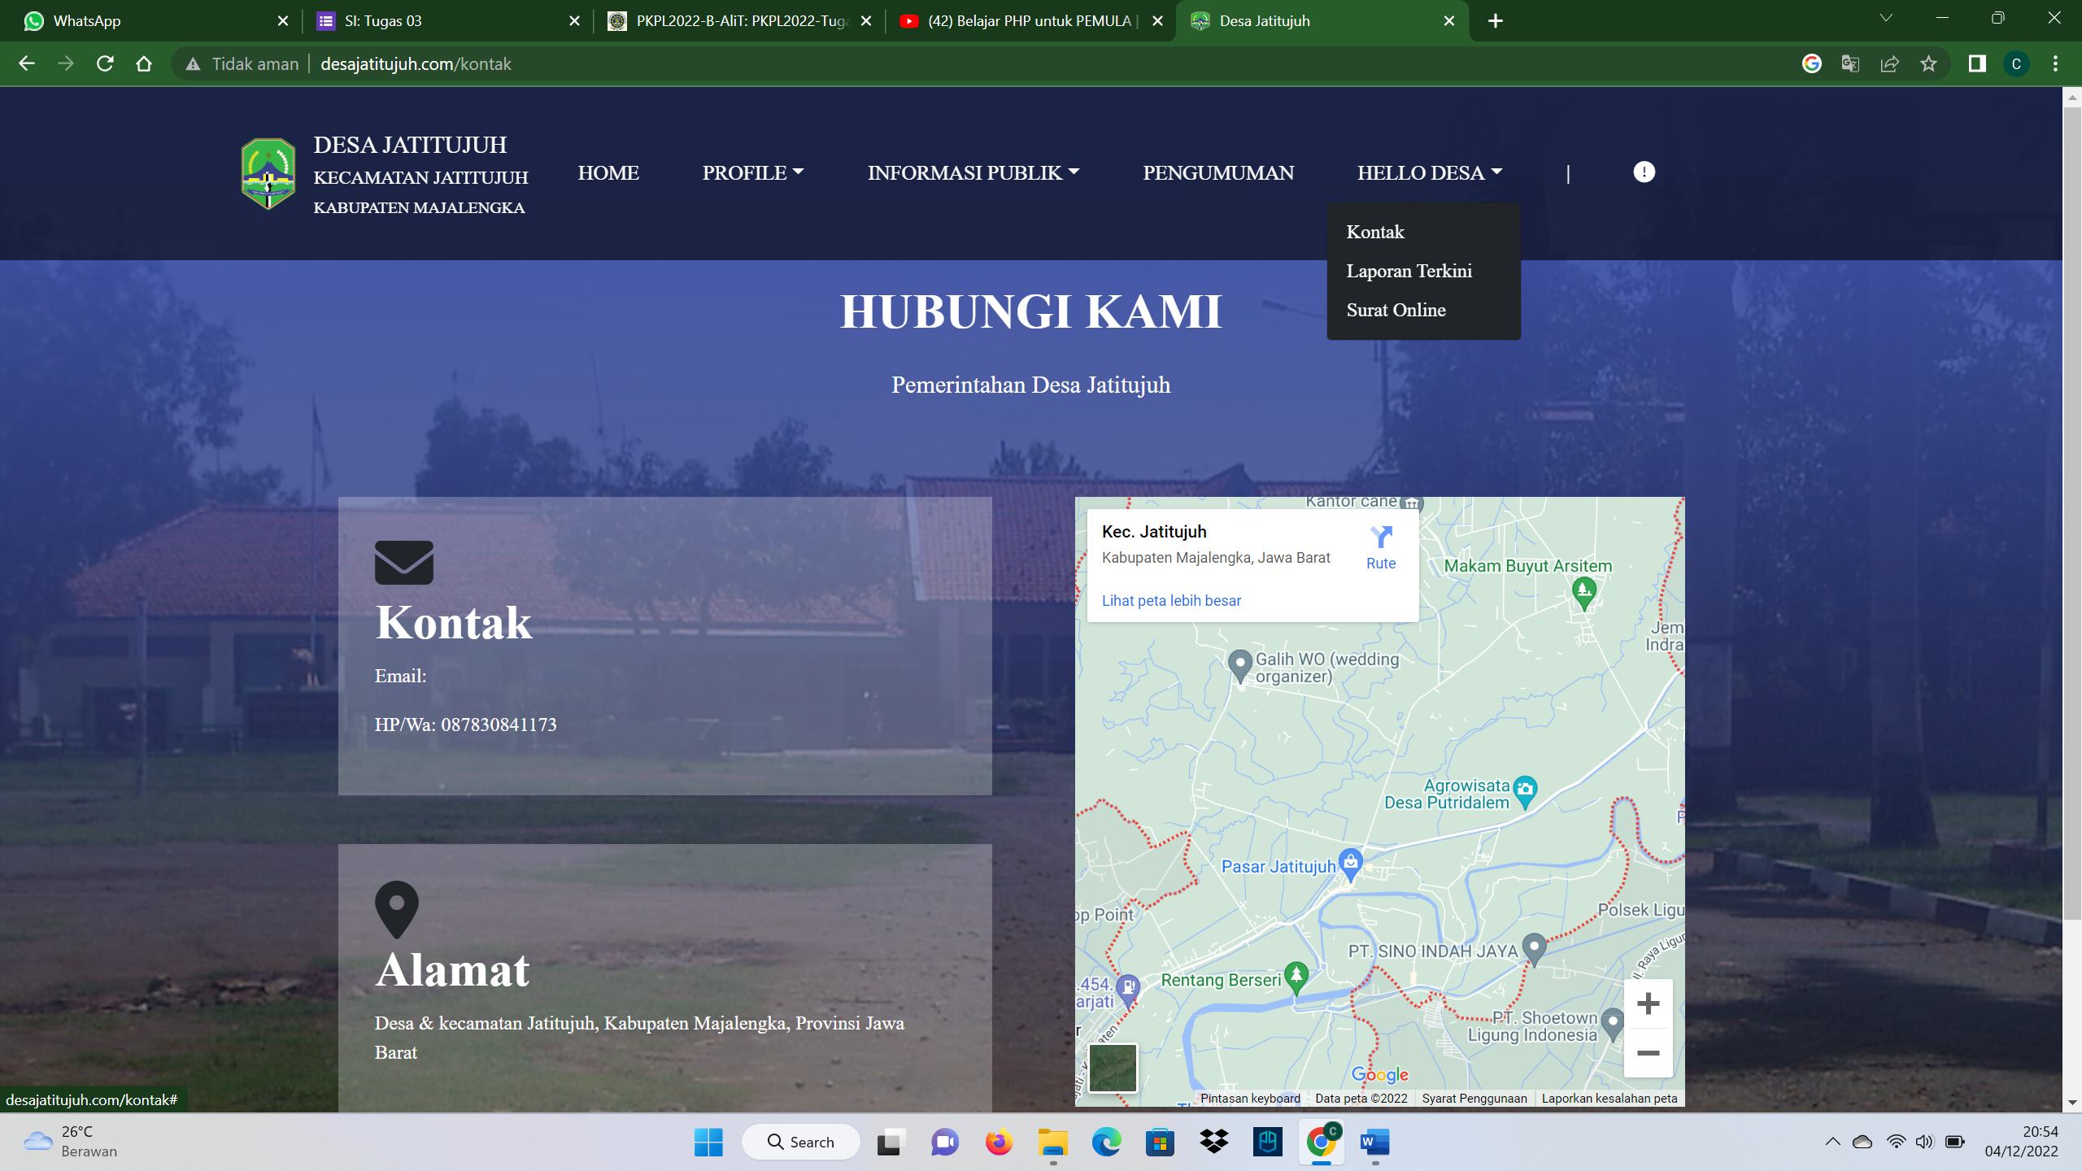

1. Rekomendasi

Berdasarkan hasil review diatas yang dapat saya rekomendasikan adalah Menu Home karena berisi informasi yang lengkap dan jika ada informasi yang terupdate maka informasi tersebut ada pada Menu Home tersebut. Jika ada berita yang masuk seperti berita desa tersebut masuk kedalam informasi public, dimana didalam informasi public terdapat informasi berita desa ,event desa dan galeri.

Pada fitur website ini juga terdapat menu pengumuman dimana admin harus memasukkan pengumuman tersebut agar dapat dilihat oleh warga. Didalam tampilan disini terdapat menu Hello Desa menurut saya sendiri fitur hello desa ini harus diganti Namanya kurang pas jika dinamaain fitur Hello Desa karena didalammnya terdapat laporan terkini, kontak, surat online.

1. Kesimpulan

Kesimpulan saya adalah dari website <http://desajatitujuh.com/>

Tampilan sudah sangat bagus dan fitur-fitur nya sudah lengkap.

Berdasarkan pengujian white box dan black box uji ini sangat berhasil tidak ada kesalahan atau error pada menu website tersebut.